- Restrict the "List of Orders" table to only the first 500 rows.

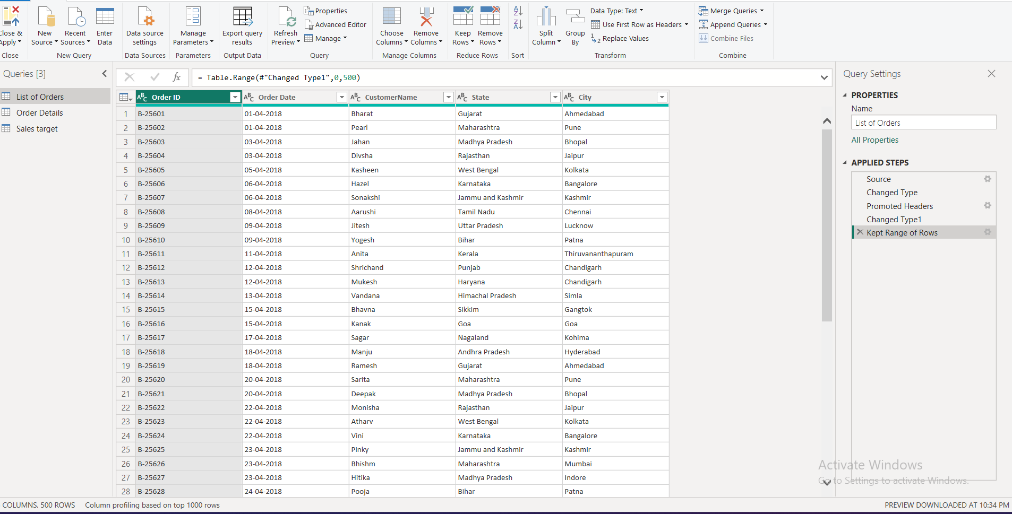

- Ensure the “Order Date” column in the “List of Orders” table is set to data type 'Date'.

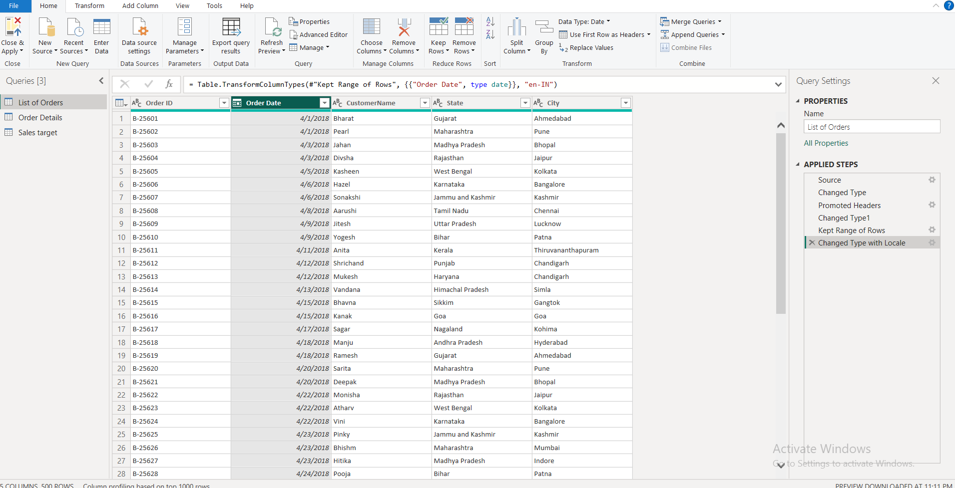

- Change the data type of “Amount” and “Target” columns to ‘Fixed Decimal Number’.

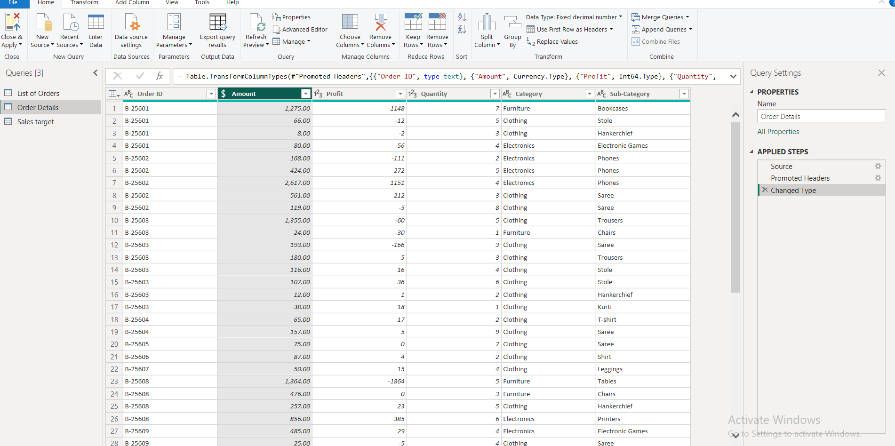

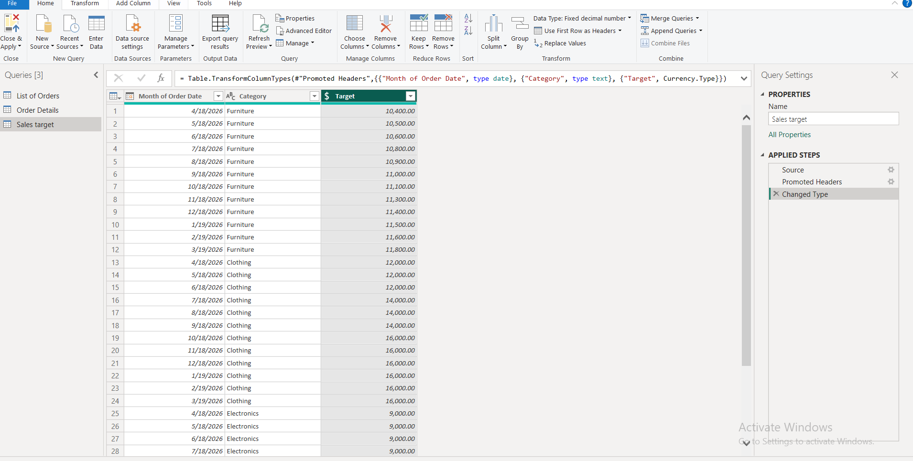

4.Format the "CustomerName" column into proper case, ensuring consistent
capitalization for each word.

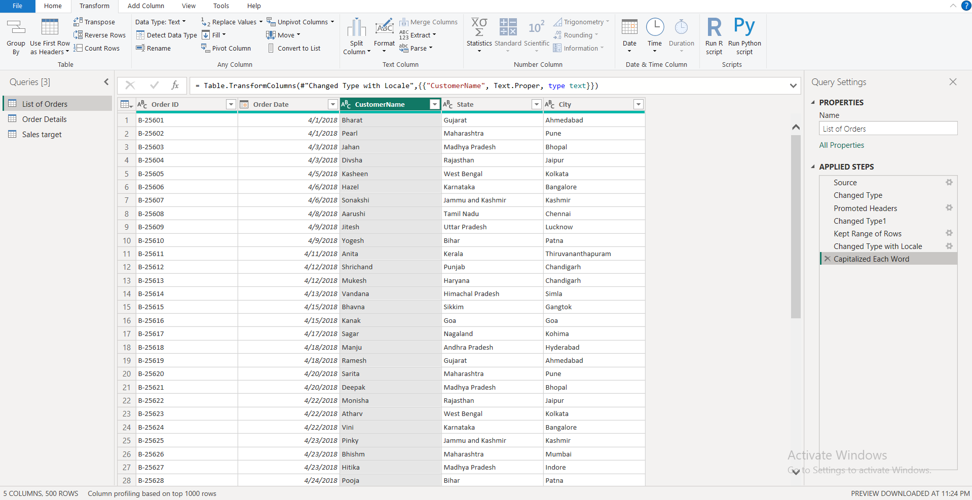

5.Merge the "State" and "City" columns to create a new column named "Location" in the format ‘City, State

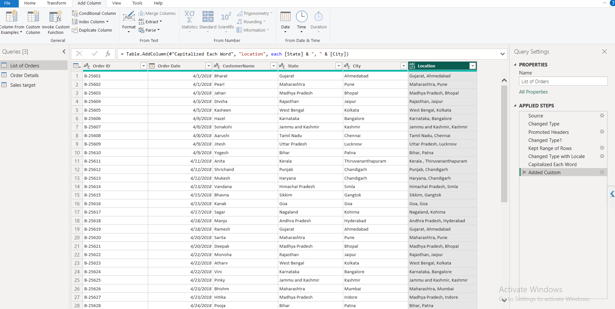

6.Create a new custom column named "Profit Margin" as the percentage of "Profit" divided by "Amount".

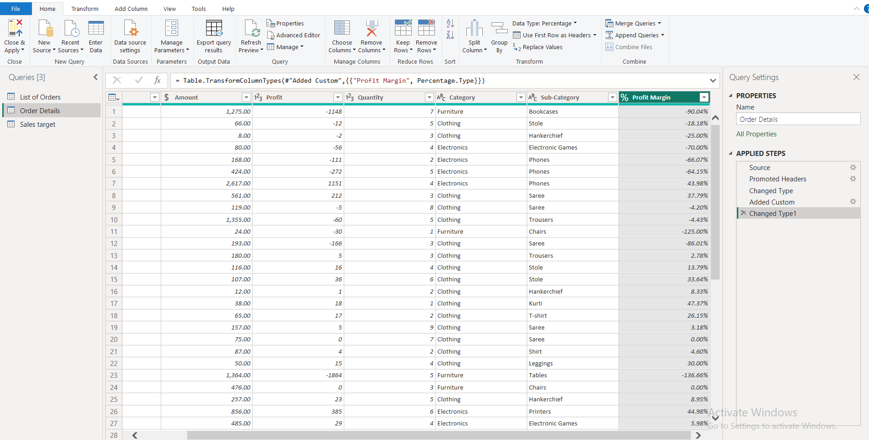

- Add a new conditional column named "Profit Status" based on the values in the "Profit" column. The conditions are as follows: if the profit is less than 0, the label should be "Loss"; if the profit equals 0, the label should be "Break-Even"; and if the profit is greater than 0, the label should be "Profit"

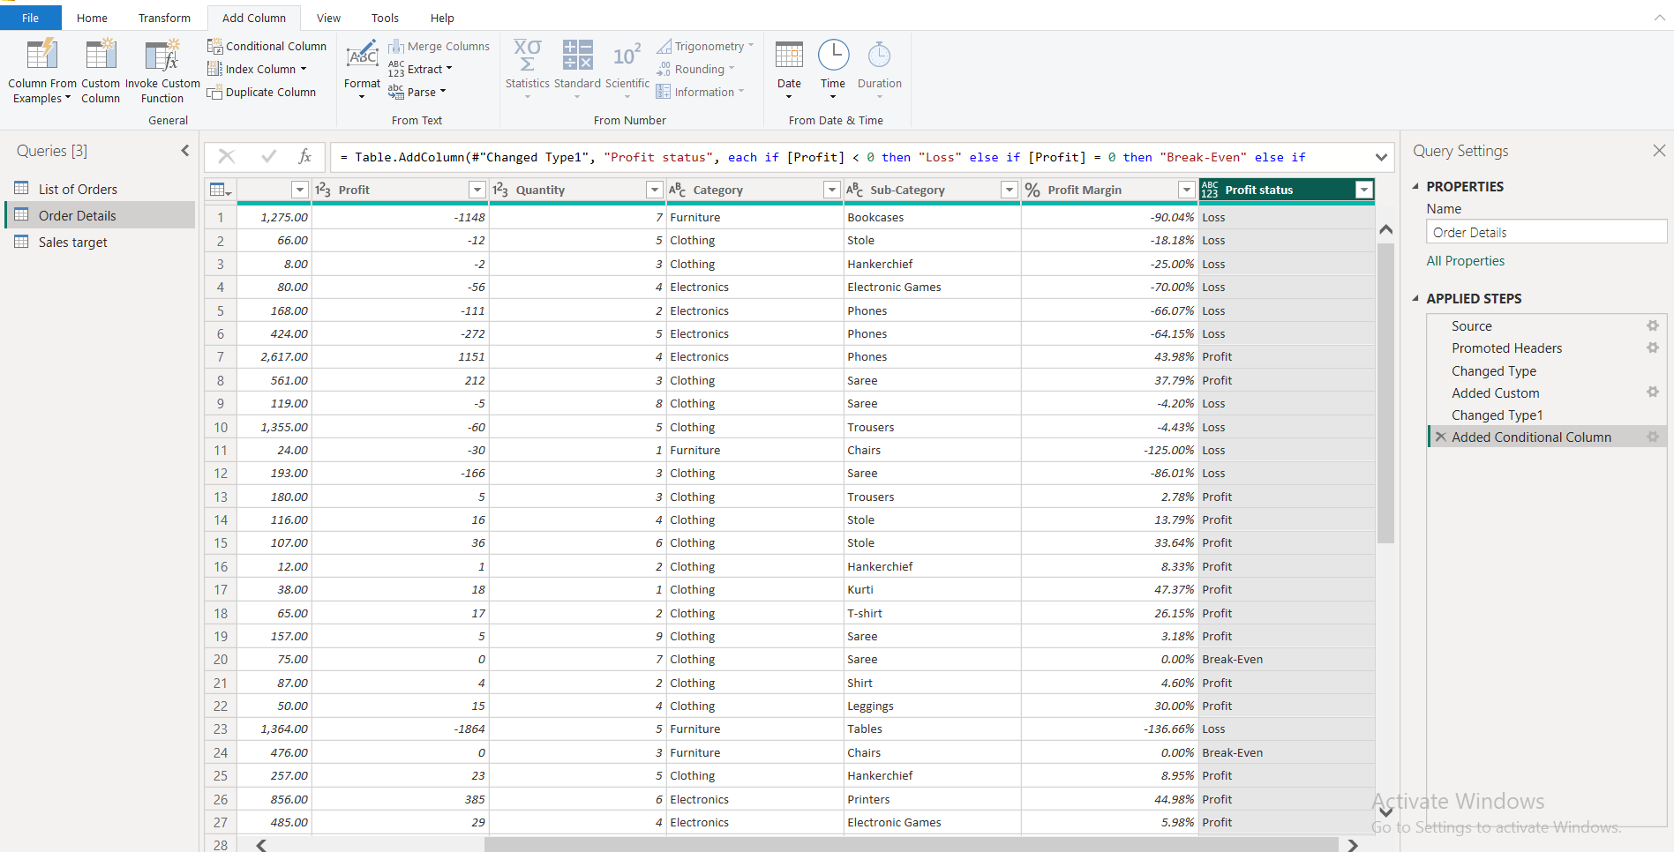

Merging Data (Joins):

Merge the "List of Orders" and "Order Details" tables into a new single table named "Orders Data" based on the "Order ID" relationship

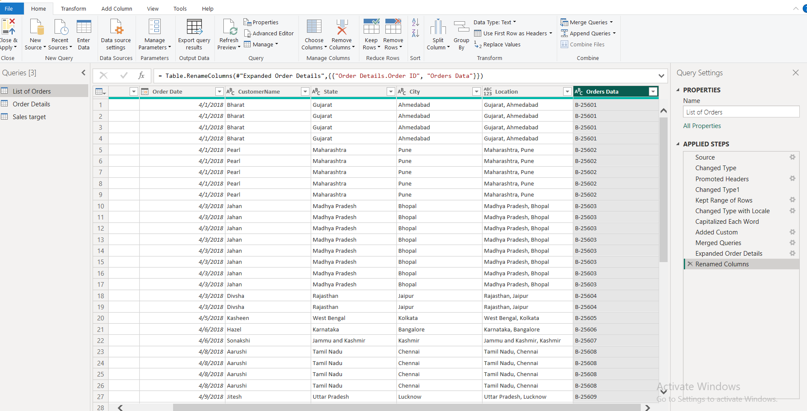

Handling Missing Data & Duplicate Data:
● Identify missing values in the data and determine a strategy to address them.

No Missing values in the Data

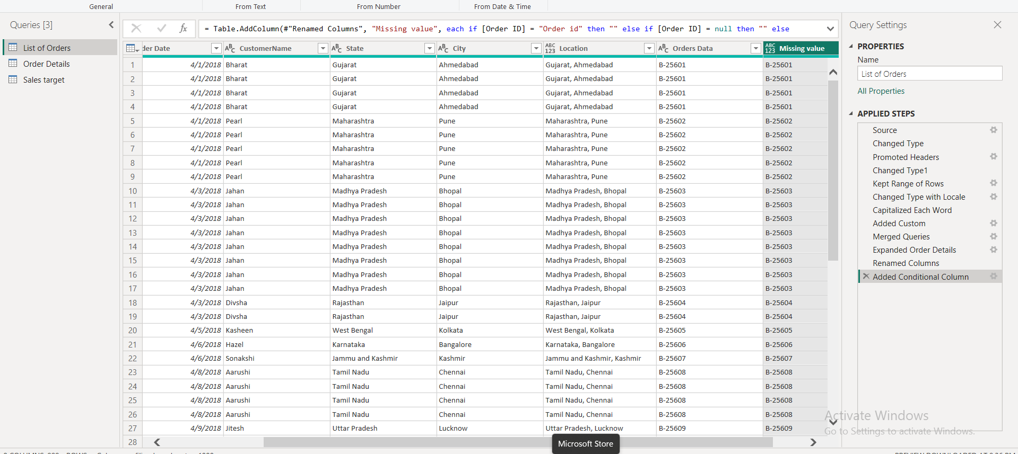

Check for duplicate rows and define a strategy to handle duplicates

No duplicates in the table

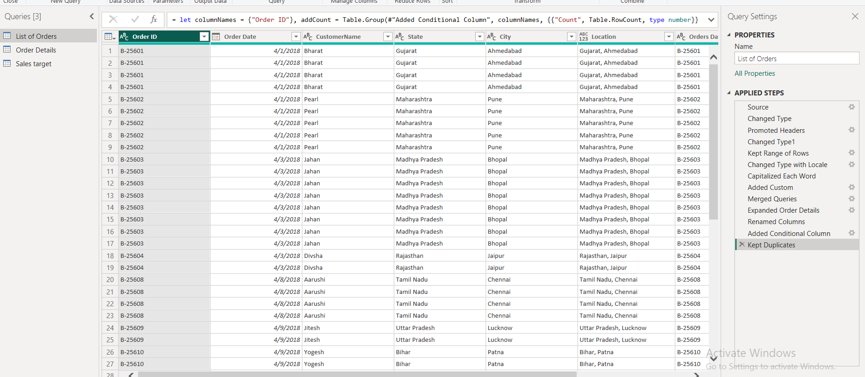

Sorting and Filtering Data:

In the ‘Orders Data’ table, utilize sorting and filtering techniques on columns like Order Date, State or Category to analyze data based on specific criteria:

Sort the orders by Order Date in descending order to analyze recent trends.

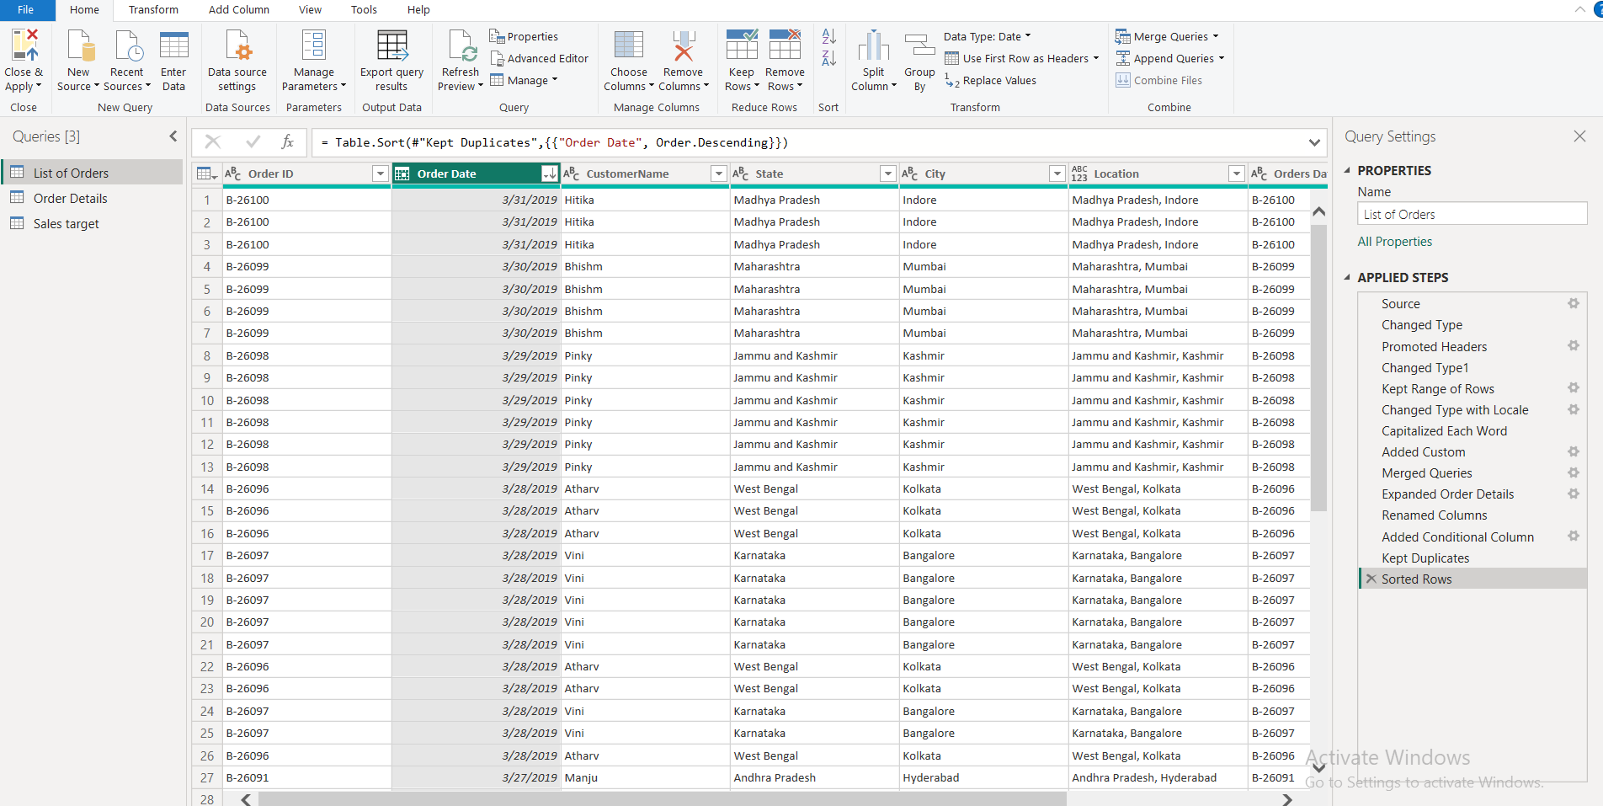

Filter the orders to focus only on a specific state (e.g., Tamil Nadu) for
regional analysis.

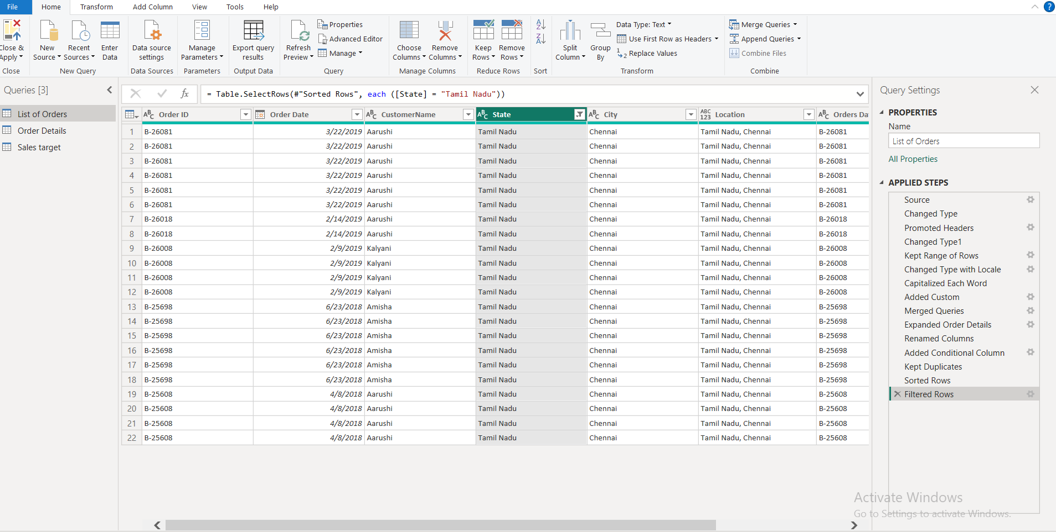

Grouping and Aggregating Data:

Duplicate the “Order Details” table and calculate the count of each Order ID, average profit by Category or total amount by Sub-Category

Count of Orders ID

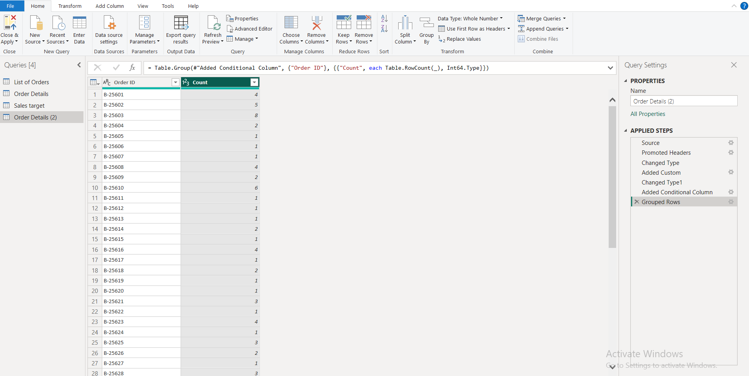

Average profit by Category

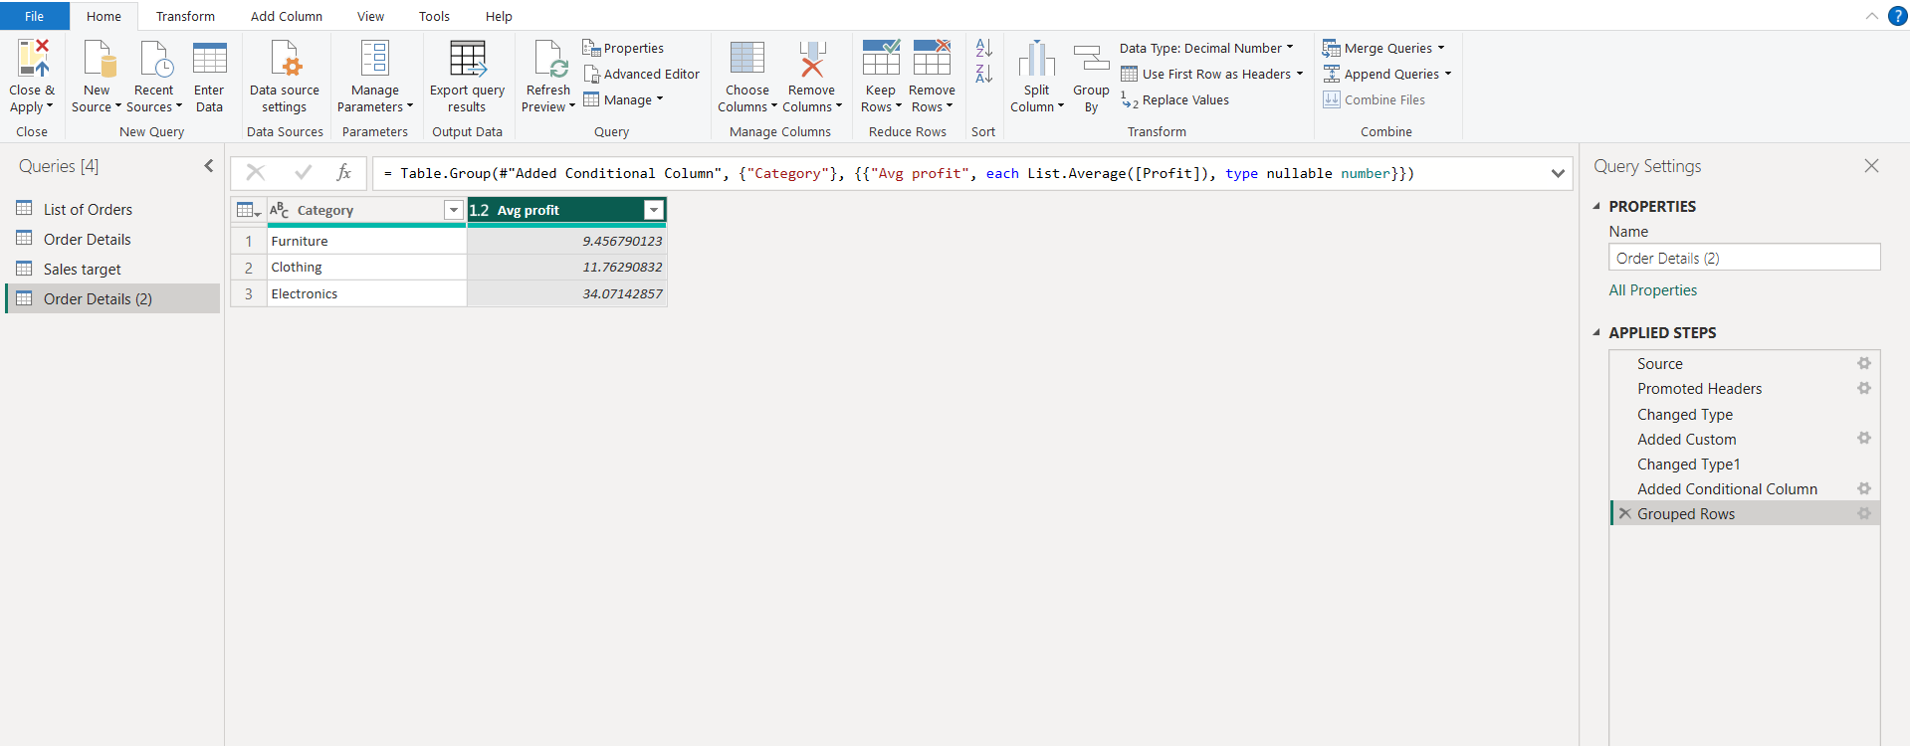

Total Amount by Sub-Category

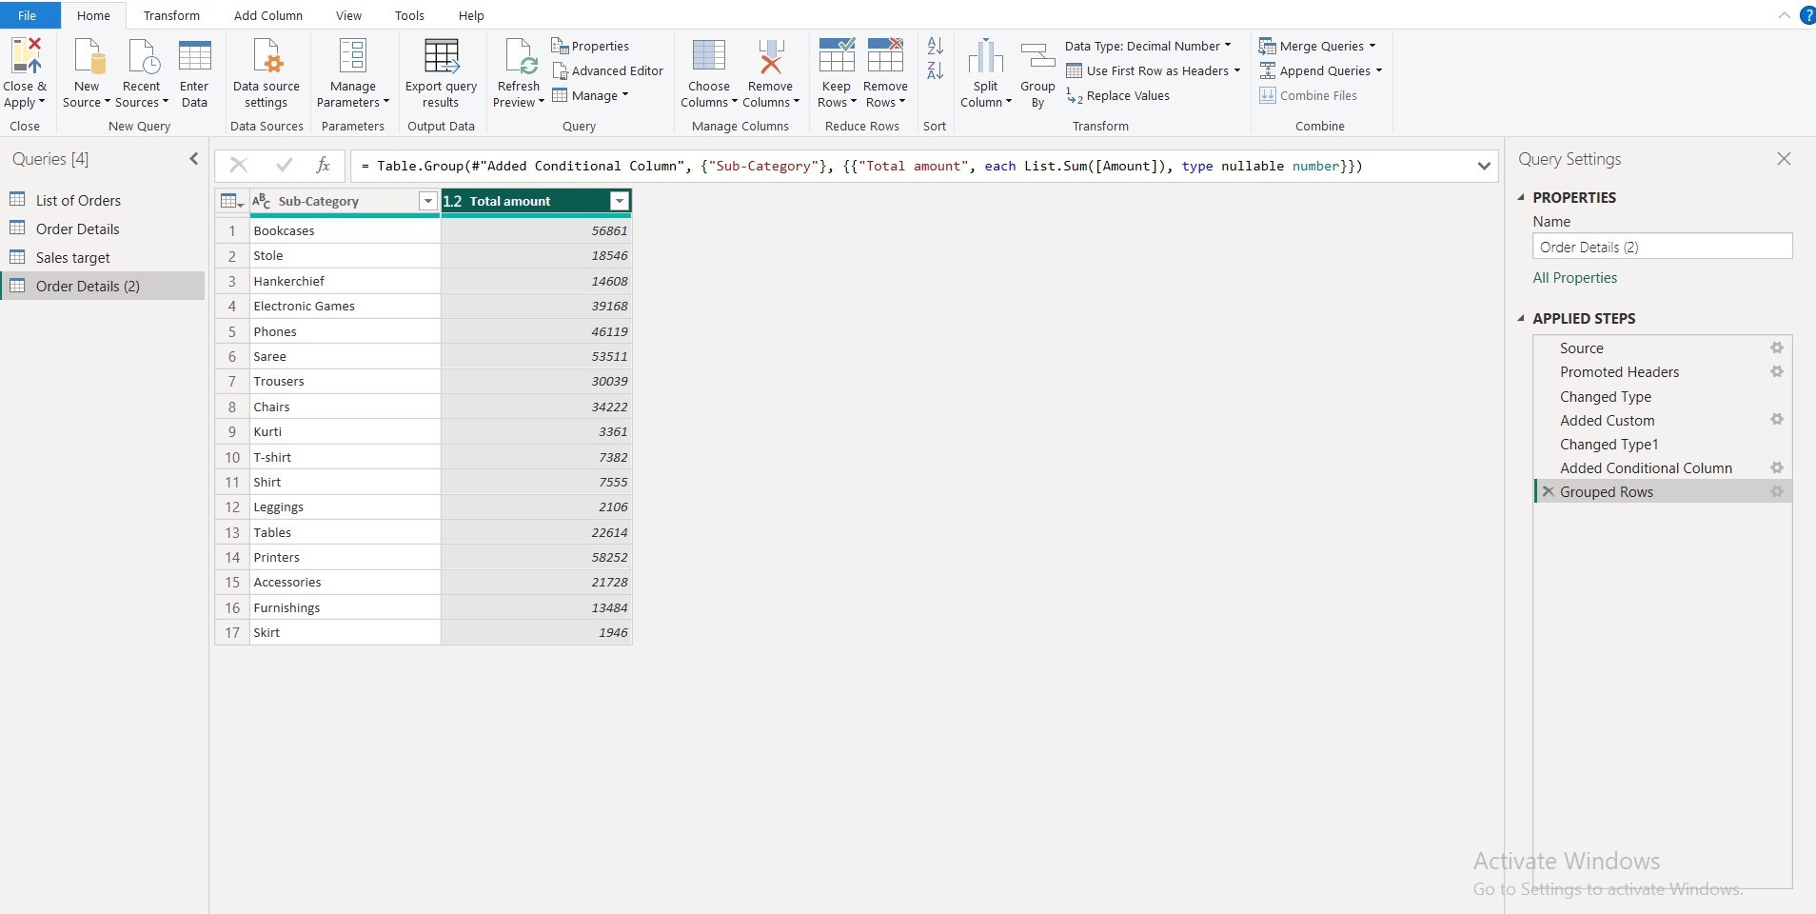

Duplicate the “Sales Target” table and aggregate the total target amount by Month of Order Date

Total target of Month of order Date

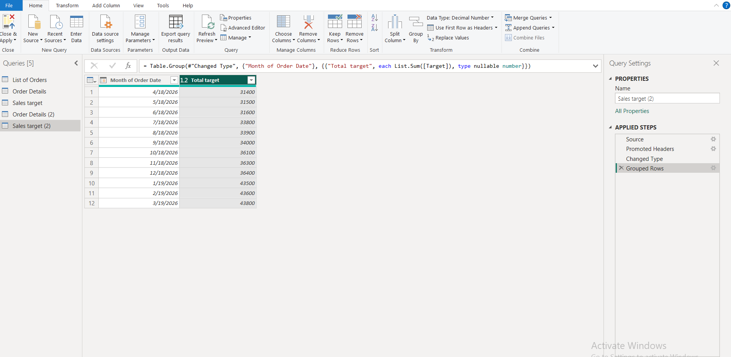

Data Modeling:

Establish a relationship between the “List of Orders” and “Order Details” tables using the ‘Order ID’ column.

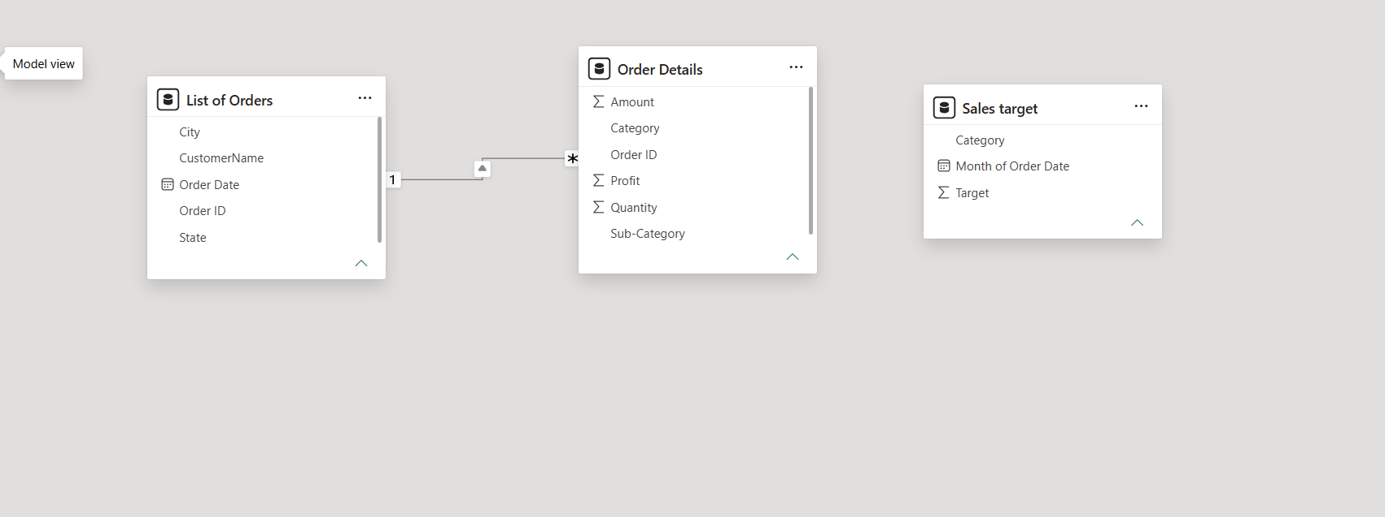

Build a relationship between the “Order Details” and “Sales Target” tables based on the ‘Category’ column. Click "Manage relationships" and ensure this relationship is active.

